**LORENCIA JUNIOR SCHOOL-NSANGI**

**PRIMARY FIVE**

**ENGLISH RECESS WORK SET TWO**

**Name:**

### Section A

**For each of the questions 1 to 5, fill in the space with the correct word or group of words.**

1. The driver reminded the to fasten their seat belts.
2. you go to the tax park, you won’t find a taxi to your home.
3. It is to disobey teachers.
4. A pair of pliers is important tool in the tool box.
5. Ritah dictionary got lost is coming soon.

### In each of the questions 6 to 15, use the correct form of the word given in the brackets to complete the sentences.

1. Our class the best song of all. (sing)
2. Rinah is the of the two brothers. (lazy)
3. If my Dad to the North, he will cross Karuma bridge. (travel)
4. All the _ agreed with their King. (chief)
5. My friend is a . (cartoon)
6. The passengers reached their destination _. (safe)
7. December is the __ month of the year. (twelve)
8. All the thieves burnt to death. (to be)
9. My uncle keeps a number of on his farm. (goose)
10. Can a pregnant mother use a belt? (sit)

### In questions 16 and 17, arrange the give words in alphabetical order.

1. ticket, travel, taxi, time
2. force, name, game, story

### In each of the questions 18 to 19, re-write the sentence giving the opposite of the underlined words.

1. The arrival time for Gateway bus is 12:00 noon.
2. There were beggars at the exit of the church.

### In each of the questions 20-22, re-write the sentence giving the plural of the underlined word.

1. Everybody in the line was holding a ballot paper.
2. He took the tyre to a mechanic.
3. The teacher gave me a bar of soap.

### For questions 23 and 24, use each of the words in a sentences to show that you know the difference in their meanings.

1. leave: _
2. live:

### In each of the questions 25 and 26, re-write giving one word for the underlined group of words.

1. His photograph appeared on the page of a newspaper where headlines are

printed.

1. There were few people travelling in the bus.

### In each of the questions 27 to 28, write the given short forms in full.

27. Rd: _

28. w.e.f: _

### In each of the questions 29-30, arrange the given words to form a correct sentence.

1. newspaper reading you are Which?
2. good What columnist is Wafula a!

### In questions 31 to 50, re-write the sentences as instructed in the brackets.

1. She forgave me. I broke her ruler, (Re-write using …..for….)
2. These are the spare parts. Martha bought them yesterday. (Re-write using …. Which….)
3. Opera turned to the back page of the newspaper. He wanted to read the sports new. (Use………….in order )
4. Francis lent five thousand shillings to Jacob. (Re-write using ….borrowed……)
5. He will get money and repair the vehicle. (Begin: If… )
6. Their team played well but they didn’t win the match. (Re-write using….although )
7. They will visit us next month, ? (Supply a suitable question tag)

_

1. Mukuku read many newspapers. He wanted to find a job. (Use …so as…)
2. Gladys is very weak. Gladys cannot carry that table. (Use ….…enough…….)

_

1. That question is very bad. I can’t attempt it. (Use …too…to…)
2. There aren’t any mangoes in the basket. (Use ….some )
3. Hillary owns this car. (Re-write Ending…..Hillary’s car.)
4. The lady went to the police station. Her bag was stolen. (Join the sentences using ….whose…..)

_

1. We reached the hospital after mid-day. (Use ..arrived…)

_

1. It is difficult to teach lazy children. (Re-write ending …….is difficult)
2. We shall go home if the teacher gives us permission. ((Use…....unless )
3. You are a very kind man. (Begin: What… !)
4. An elephant is very strong. A buffalo is strong. (Use…..stronger…….)
5. Jane is a hero. Henry is also a hero. (Begin: Both )
6. When I am at home, I enjoy washing more than peeling. (Re-write using …………..…prefer )

### SECTION B

**Read the passage below carefully and in full sentences, answer the questions that follow.**

### A BREAK DOWN TRUCK

A break down truck is used for towing other vehicles that have broken down. A break down truck has a long chain onto which a broken down vehicle is connected and then pulled to the **garage.**

A break down truck is very helpful because without it, it would be very difficult to push or pull heavy vehicles like lorries, buses or trailers which break down along the road.

There are very many break down trucks in different parts of Kampala and elsewhere in the country **for example** Katwe, Ndeeba, Nateete and others. These trucks offer services

to the community. Whenever a vehicle breaks down, the traffic police and vehicle owners hire break down trucks to tow it to the garage or police station.

### Questions.

1. What is the break down used for?
2. Where is a vehicle taken when it breaks down?
3. In which area can one get a break down truck?
4. Why is a break down truck very helpful?
5. According to the passage, which vehicles are heavy?
6. What is used to connect a vehicle to a break down?
7. Why do people hire break down trucks?
8. Why do you think break down vehicles are mainly towed to the garage?

_

1. Write one word or group of words with the same meaning as the underlined words in the passage.
   1. garage:
   2. for example:

### Read the poster below carefully and then answer the questions in full sentences.

**Football! Football!**

Eagles FC Vs Doves FC

Venue: Mandela National Stadium When: 25th April, 2020

Kickoff: 4:00pm

Fees: Adults -3000/= Children: 1000/=

Come one

Come all

**(Andrew Kamatsiko, sports officers)**

**Questions**

1. Where will the football match take place?
2. Which teams are going to play?
3. When will the match take place?
4. How much will each adult pay to watch the match?
5. At what time will the match start?
6. How much will a 10-year old boy pay to watch the match?
7. Write Vs in full.
8. Who wrote the above poster?
9. Who are invited to watch the match?
10. Apart from football, name any other game played in your school.

### Read the poem below and answer questions about it in full sentences.

Newspapers! Newspapers!

Published daily, weekly or monthly Covering all events of the day

Be it good or bad Containing all life stories

Politics, sports, business, fashion e.t.c

Newspapers! Newspapers! A big bold printed headline Appears on the front page

To attract customers and news readers News is gathered by journalists and reporters Checked by the news editor

In order to simplify before being published.

Newspapers! Newspapers!

Found everywhere, found any where Read by anybody and every body

The letters to the editor, advertisements Puzzles editorials, pictures, cartoons Make the papers very interesting

To all persons and every person Whether rich or poor.

### By Jimmy

**QUESTIONS**

1. What is the poem about?
2. When are the newspapers published?

__

1. What does the newspaper cover?
2. What do newspapers contain?
3. Why is the headline printed in bold letters?
4. Who gathers the news?

_

1. Who checks the news according to the poem?

_ ___

1. Where can one find newspapers?
2. Why do you think newspapers are helpful?

__

1. Who reads the newspapers?

### The sentences below are not arranged in order. Re-arrange them to make a good story about the Leopard and the Hare.

1. One day, he saw Hare walking along the path.
2. Leopard was a cunning animal.
3. He said “Hare is a greedy animal, so I can trick him”.
4. He used to trap many animals and eat them.
5. As Hare was passing, he saw meat on the stick.
6. He used some magic power to put some pieces of meat on a stick.
7. Hare came to eat the meat.
8. Leopard saw Hare salivating.
9. Hare cried and pleaded with Leopard to help him get off the trap.
10. When Hare tried to eat the meat, his mouth got glued on to the stick.

### Use the words in the table below to complete the story.

of term examinations make us very busy. This business starts when the examination is out. We start revision. This revision is done by with the help of .

It is usually _ for a pupil to perform well if he or she does not

that’s _ we revise hard so as to get good results in our exams.

I therefore, all my friends to always revise their books. This will

them to improve on their performance.

|  |  |  |  |
| --- | --- | --- | --- |
| pupils , | difficult , advise | teachers , revise, | serious , time table |
| End, | help, why |  |  |

***GOOD LUCK***

**LORENCIA JUNIOR SCHOOL – NSANGI PRIMARY FIVE**

**MATHEMATICS RECESS WORK SET II**

### NAME:

**SECTION A**

1. Add: 7 3

+ 2 7

6. What number is represented by the tallies below?

1. Work out:

## 7  5

9 9

7. Share 125 oranges among 5 girls

equally.

1. What is the next number in the sequence?

0, 4, 8, 12, _

8. List down all the factors of 12.

1. Draw a cylinder in the space provided below.
2. One book costs shs 500. Find the cost of 4 similar books.

1

1. What is 7 of 21?
2. Write in words: 2405
3. Shade RS

### R S

1. Write 29 in roman numerals.
2. Change 2 4 into an improper

## 5

fraction.

1. Measure the length of the line below.

I I

A B

1. Given that  represents 8 apples. How many apples are represented by     ?
2. Represent 3054 on the abacus. TH H T O
3. Subtract: **Weeks Days**

7 5

- 3 6

1. How many triangles does the figure below have?
2. Peter had sh. 5000 in his pocket. He bought a piece of bread at sh. 3500. How much was he left with?
3. What number has been expanded to get;

(9 x 1000) + (6 x 100) + (5 x 10)

### SECTION B

(c) Add:

## 1  2  2

(2marks)

21(a) How many lines of symmetry does

the figure shown below have?

(1mark)

ii) Name the shapes below. (1mark@)

ii)

## 7 7 7

7

(c) A water tank was 8 full of water.

## 4

We used 8 of the water. What

fraction was left. (2marks)

1. Use the Venn diagram below to answer questions that follow;

### w x

y

a r

e

h

t

(b) Draw a kite. (1mark)

22a) Find the missing number. (1mark)

1 =

4 12

1. List the elements of set w. (1mark)
2. Find n(wx) (1mark)
3. Find (x – w) (1mark)
4. Find wx (1mark)
5. Use >, < or = in the following statements. (1mark@)

(d) Find the difference between the highest and the lowest mark. (2marks)

(a) 78 87

(b) 4 x 3 4 + 3

1. 2 dozen 18 books

26. (a) Take away 23,864 from 48,275 (2marks)

1. XXIV XXVI
2. Tom scored the following marks in end of year exams.

|  |  |  |  |  |
| --- | --- | --- | --- | --- |
| **Subjec**  **t** | **En**  **g** | **Math**  **s** | **SS**  **T** | **Sci**  **e** |
| **Marks** | 75 | 92 | 85 | 68 |

1. What was his best subject? (1mrk)
2. How many more marks did he get in Social studies than in Science?

(2marks)

1. Find the total marks Tom scored in all the subjects. (2marks)
2. Multiply 340 x 20 (2marks)
3. Divide: 4 3784 (2marks)

27. a) Find the LCM of 6 and 9. (2marks)

1. List all the factors of 27. (2marks)
2. List the odd numbers between 2 and
3. (1 mark)

28a) Below is a rectangle.

10cm

5cm

* 1. Find the total distance around the figure. (2marks)
  2. Work out its area. (2marks)

29. Use the price list below to answer questions that follow. (2marks)

|  |  |
| --- | --- |
| **Item** | **Price for each item** |
| Sugar | shs 4800 each kg |
| Rice | shs 3000 per kg |
| Soap | shs 2000 each bar |

1. What is the cost of 3kg of rice?
2. i) Twaha bought all the items in the list above, how much did he pay altogether?

ii) If he went with a sh. 10,000, how much money did he remain with?

30(a) Round off 42,652 to the nearest thousands. (1mrk)

(b) Write 28,457 in expanded form. (2mrks)

c) Which number has been expanded to give; (2mrks)

70000 + 5000 + 900 + 80 + 1

1. The tally table below, shows the number of pupils that were absent in week one of term three in P4 Qatar. Use it to answer questions that follow.

|  |  |  |
| --- | --- | --- |
| **Days** | **Boys** | **Girls** |
| Monday | //// | /// |
| Tuesday | // | //// |
| Wednesday | ~~////~~ /// | ~~////~~ / |
| Thursday | // | / |
| Friday | / | /~~///~~ //// |

1. How many pupils were absent on Tuesday? (1mark)
2. Which day had the highest number of girls absent? (1mark)
3. How many more boys were absent on Wednesday than girls? (1mark)
4. How many pupils were absent in the whole week? (2marks)
5. The graph below shows the number of pupils who visited the zoo in 5 days.

80



|  |  |  |  |  |
| --- | --- | --- | --- | --- |
|  | |  |  | |
|  |  |
|  |  |
|  |  |

70

60

**Number of pupils**

50

40

30

20

10

0

### Mon Tue Wed Thur Fri Days of the week

1. On which day did the highest number of pupils visit the zoo? (1mark)
2. How many pupils visited the zoo on Friday? (1mark)
3. On which days did the same number of pupils visit the zoo? (1mark)
4. How many pupils visited the zoo in five days altogether? (2marks)

***Good Luck***

**LORENCIA JUNIOR SCHOOL – NSANGI PRIMARY FIVE**

**SCIENCE RECESS WORK SET II**

# NAME:

**SECTION A**

1. What is air?
2. Give one example of a root tuber.
3. Why do objects like leaves float on water?
4. How can people in a community prevent the spread of cholera?
5. Why is it bad to share a house with animals?
6. Name one poultry disease caused by virus.
7. Why do we cut our finger nails short?
8. Why are houseflies dangerous in our society?
9. Name the type of soil that is suitable for pottery.
10. Name the type of soil formed by decomposition.
11. Why do we wash hands with clean water and soap after visiting the toilet?
12. Identify the type of worm which enters our body when we eat half cooked meat.
13. How are nimbus clouds useful to a crop farmer?
14. Why do bees visit flowers?
15. What is personal hygiene?
16. Which component of air occupies the highest percentage in the atmosphere?
17. Give the main part of a plant which manufactures food.
18. How is too much rainfall a dangerous to man?
19. How are gills important to a fish?
20. What is the use of feathers to a bird?
21. What main food value do we get from eating foods rich in proteins?
22. State the role of a drone bee in a hive.
23. State one activity a P5 pupil can perform at school to improve sanitation.
24. Why do some plants climb others?
25. Which garden tool is used for transplanting seedlings?
26. Name the gas that is required for rusting to take place.
27. How does smoke move through the chimney of a kitchen?
28. What term means the mixture of two or more metals?
29. Why is decay important to the soil?
30. Name the type of tooth shown below.



1. Why do insect-pollinated flowers have brightly coloured Petals?
2. Mention the body organ that aids in memory.
3. What type of bees make honey in a hive?
4. State the function of a micropyle to a germinating seed.
5. Give one reason why tsetse flies should be controlled.
6. Name the instrument used to measure human body temperature.
7. Name the force which makes water run freely on the surface of the land.
8. Suggest one reason why communities should fence open springs.
9. Which mineral salt strengthens our bones and teeth
10. What is soil profile?

**SECTION B**

### The table below shows weather instruments and what they measure. Match the items in list A with those in list B.

|  |  |
| --- | --- |
| **List A** | **List B** |
| Wind vane | Amount of rain |
| Barometer | Speed of wind |
| Rain gauge | Amount of air pressure |
| Anemometer | Direction of wind |

* 1. Wind vane _
  2. Barometer _
  3. Rain gauge _
  4. Anemometer _

42(a) Mention two importances of keeping poultry.

3. Which system of keeping poultry is common in rural areas?
4. Name one poultry disease which is also common in rabbits.

43. Below is a diagram of soil layers. Answer the questions about it.

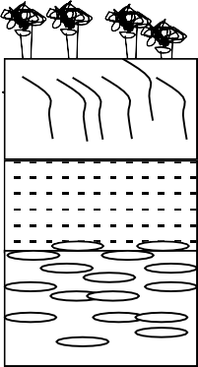 X (a) What scientific name is given to the

arrangement of soil layers shown?

Y

* 1. Name the layers marked.

Z (i) X

(ii) Z

* 1. Give any one use of soil to people.

44(a) Why are honey bees said to be social insects?

1. Give one way in which bees improve crop yields in a garden.
2. Name the female sterile bee in a hive.

45.a) What are flowering plants?

1. Identify any two non-flowering plants.

4. How do most non-flowering plants reproduce?

46a) Mention two activities done to keep your body clean.



(b) Give the importance of these materials used to keep our bodies clean.

1. comb:
2. sponge:

47. **The diagram below shows parts of an insect. Use it to answer questions that follow**

**P H**

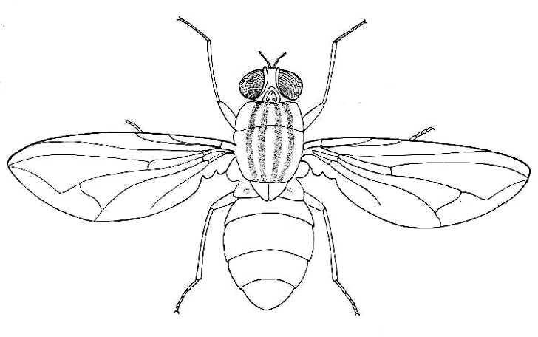

**Z**

1. Name part marked P and Z
2. P
3. Z
4. How is part H useful to the insects?
5. Why is a spider not a true insect?

48a) What is pollination?

1. Name any one type of pollination.
2. What is the role of a bee in the process of pollination?
3. Give any one characteristic of insect pollinated flowers.

49(a) Identify any two components of soil.

* 1. ii)

1. Which type of soil has the largest particles?
2. Suggest one way in which soil fertility can be maintained.
3. a) What is wind?
4. Which part of air occupies the largest percentage of the atmosphere?
5. Give one use and one danger of wind to the environment.
   1. Use:
   2. Danger:
6. The diagram below shows a bean seed. Use it to answer questions that follow

M

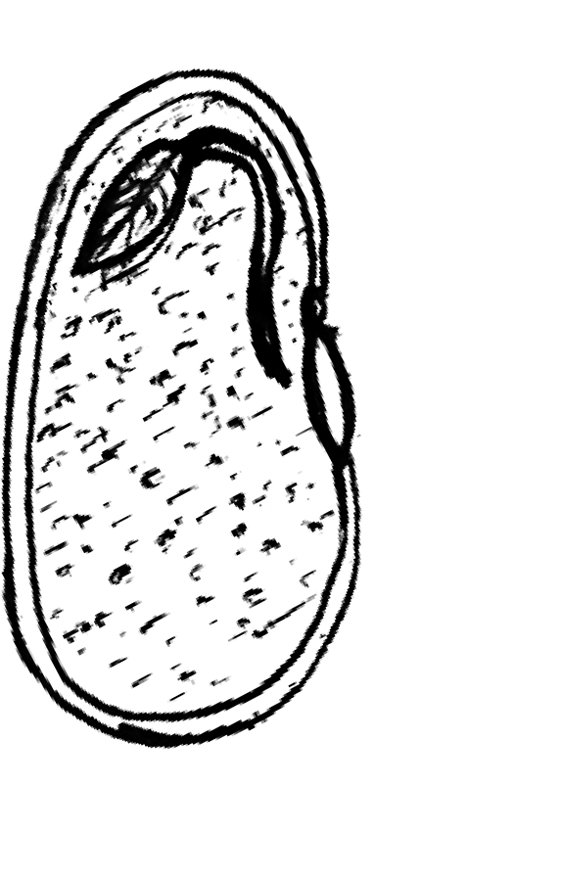

X P

1. Name the parts marked X and P with letters;
   1. **X**
   2. **P**
2. What does part marked M become after germination?
3. What type of germination does a bean seed undergo?

52.(a) Name one type of poultry kept by farmers.

1. Apart from eggs, give one other product from poultry.
2. Why is deep litter system the most suitable system for urban commercial poultry farming?
3. How do crop farmers benefit from poultry keeping?

53.(a) State the function of the following types of teeth.

* 1. canines
  2. incisors

1. Mention two ways of caring for our teeth.

   2. 54(a) What is First Aid?
2. State the main reason for giving First Aid to a casualty.
3. Name any two items found in a First Aid box.

55. *The diagram below shows the life cycle of an insect. Use it to answer questions that follow.*

Eggs

W

Z

Pupa

1. Name the type of life cycle shown above.
2. Name the stages shown by the letters W and Z.
   1. W:
   2. Z:
3. Give one example of insects with such a life cycle.

**LORENCIA JUNIOR SCHOOL – NSANGI PRIMARY FIVE**

**SOCIAL STUDIES RECESS WORK SET II**

# NAME:

### SECTION A

1. Name the means of communication used at school.
2. Give one example of a Lake formed by the result of down warping in Uganda.
3. State the region of Uganda where your district is found.
4. Mention one Island district in Uganda found on Lake Victoria.

__

1. Who is the political head of a sub-county?
2. Mention the use of a key on a map.
3. What is a community?
4. Give one importance of a school to people who live near it.
5. What is the opposite direction of South West.
6. Name the instrument that helps a map reader to find the direction of places.
7. Mention the line of Latitude marked 0o.
8. What is a hemisphere?
9. Give any one neighbouring country of Uganda that is land locked.
10. Give one reason why every school should have a fence.
11. State one importance of planting grass on a school compound.
12. Name the country found in the East of Uganda.
13. Which physical feature covers the largest part of Uganda.
14. Give one example of crops grown on the valley.
15. What are escarpments?
16. Mention one inland part formed on Lake Victoria.
17. Name the mineral mined at Lake Katwe.
18. State the Lake found on the Central plateau of Uganda.
19. What is a tributary?
20. Give one example of water falls formed on River Nile.
21. In the space below draw a map symbol of a mountain Peak.
22. Give one example of an instrument found at weather station.
23. State one importance of forests to man.
24. Name one crops that grows well in swampy areas.
25. Mention one place in your community when people go to get Education services.
26. Write RDC in full.
27. Give any one cause of road accident on the roads of Uganda.
28. Give one duty of a police in our society.
29. John was going to school in the morning facing North he then turned 450 Clock wise. What is John’s new direction.
30. What is population?
31. Name the main source of water on earth.

### For each of the questions 36– 40, answer either a Christian or an Islamic question but not both in a number.

1. **Either**: Give one way God created man different from other creatures.

Or: Give one way Allah created man different from other creatures.

1. **Either:** Name the material from which God created Hawa.

**Or:** Name the material from which God created Hawa.

1. **Either.** Give any one commandment of God.

**Or:** Give any one commandment of God.

1. **Either:** State one gift of the Holy spirit.

**Or:** State one gift of the Holy spirit to Muslims.

1. **Either:** What is a prayer?

**OR:** What is a prayer?

### SECTION B

41(a) Use a map of Uganda below to answer the questions that follow.

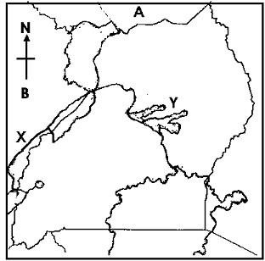

**M**

1. Name the Lake marked with letter **Y**.
2. What name is given to the highest peak of Mountain marked M.
3. State two importance of mountains to people.

42(a) What is fishing?

1. Name the commonest type of fish caught in the water bodies of Uganda.
2. Give two ways of preserving fish.

43.a) What are economic activities?

1. Give two economic activities done in and around lakes.
2. State any one problem faced by people while carrying out their economic activities.

44.a) What are land locked countries?

1. Give one problem faced by land locked countries while carrying out international trade.
2. Give two examples of land locked countries.
   1. ii) _

### 45 Complete the table below.

|  |  |
| --- | --- |
| Raw material | product |
|  | Coffee beverages |
| Oil palm |  |
|  | clothes |
| pyrethrum |  |

46(a) Who is a leader?

1. Mention any one leader in your district.
2. State two reasons why the government of Uganda is creating more districts today. (i)

(ii) 47(a) What is transport?

1. Give any two means of water transport used on Lake Victoria.
2. Name the commonest type of transport used by the people in Uganda.

48.a) Name any one mountainous district in Uganda.

1. How do people in mountainous areas solve the problem of transport?
2. Name the animals used for transport in mountainous areas of Uganda.
3. Mention the cash crop that grows well in fertile volcanic soils of Mountain Elgon.

49.a) Give two group of people who use compass in their work.

(i) __ (ii)

1. Apart from using a compass direction, give any two ways of locating places on a map.

50.(a)What is trade?

1. Name any one place where people carry out trade.
2. Give two problems faced by people when carrying out trade.

### In questions 51 – 55, answer Either Christianity or Islamic but not both.

51(a) **Either:** What is Lent period?

1. Give three things Christians are supposed to observe during lent.

**OR**(a)What is Ramadhan?

1. Give three things Muslim should observe during the month of Ramadhan.

52.a) **Either:** What is Holy trinity?

1. Name the three components of the Holy spirit.

**OR**:(a) What does Sadaq refer to?

1. Write down two items we can give as sadaq.
2. Give one advantage of giving Sadaq.
3. **Either :**(a) Name the first person that God created.
4. Why did God create the above person?
5. Which material did God used to create

Adam Eve

**Or:** Name the first person that Allah created.

1. Why did Allah create the above person?
2. Which material did God use to create

Adam Hawa

1. **Either**: a) Name the first sin to be committed by man.
2. Give the creature that tempted man to commit the first sin.
3. Mention two results of the original sin committed by man.

**OR:** a) Name the first sin to be committed by man.

1. Give the creature that tempted man to commit the first sin.
2. Mention two results of the original sin committed by man.
3. **For Both:** What is talent?
4. Give two examples of a talent.
5. Give one way we can use our talent to please God.

__

**GOOD LUCK.**